Drainage control techniques
Technique | Code | Symbol | Technique | Code | Symbol
Catch Drain | CD |  | Chute | CH | 
Diversion Channel | DC |  | Flow Diversion Bank | DB | 
Level Spreader | LS | 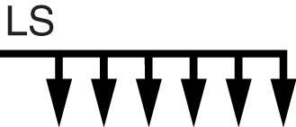 | Outlet Structure | OS | 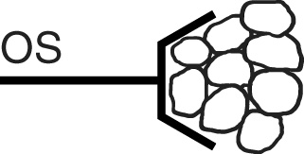
Recessed Rock Check Dam | RRC |  | Rock Check Dam | RCD | 
Sandbag Check Dam | SBC |  | Slope Drain | SD | 
Bridge | TBC |  | Culvert | TCC | 
Temporary Downpipe | TD | 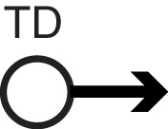 | Ford | TFC | 
Triangular Ditch Check | TDC | 

Drainage control – channel/chute lining techniques
Technique | Code | Symbol | Technique | Code | Symbol
Cellular Confinement System | CCS | 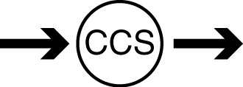 | Erosion Control Mat | ECM | 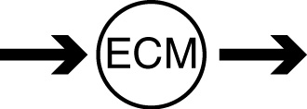
Geosynthetic lining | GEO | 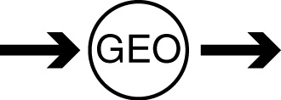 | Grass lining | GC | 
Grass Pavers | GP |  | Hard Armouring | HA | 
Rock lining | RR |  | Rock Mattress | RM | 
Turfing | T | 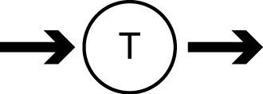 | Turf Reinforcement Mat | TRM | 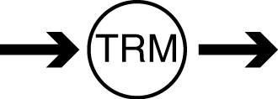

Instream flow control techniques
Technique | Code | Symbol | Technique | Code | Symbol
Cofferdam | Dam | 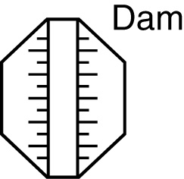 | Floating Silt Curtain | FSC | 
Geo Log | Log |  | Isolation Barrier | IB | 
Sediment Fence Isolation Barrier | SFB | 

Erosion control techniques
Technique | Code | Symbol | Technique | Code | Symbol
Bonded Fibre Matrix | BFM | 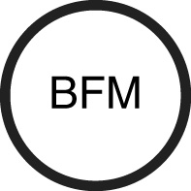 | Cellular Confinement System | CCS | 
Compost Blanket | CBT |  | Erosion Control Blanket | ECB | 
Gravelling | Gravel |  | Heavy Mulching | MH | 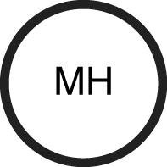
Light Mulching | M | 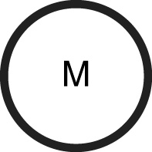 | Poly-acrylamide | Poly | 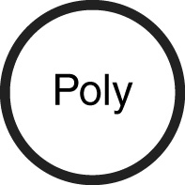
Revegetation | R |  | Rock Mulching | MR | 
Soil Binders | SBS |  | Surface Roughening | SR | 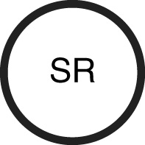

Sediment control techniques
Technique | Code | Symbol | Technique | Code | Symbol
Buffer Zones | BZ |  | Check Dam Sediment Trap | CDT | 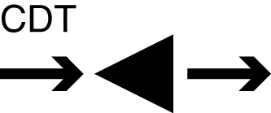
Coarse Sediment Trap | CST | 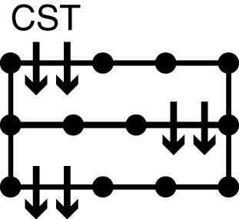 | Compost Berm | CB | 
Fibre Roll | FR |  | Filter Fence | FF | 
Filter Sock | FS |  | Filter Tube Dam | FTD | 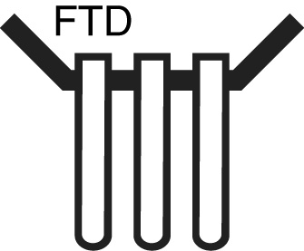
Grass Filter Strips | GFS | 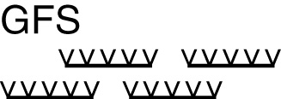 | Modular Sediment Trap | MST | 
Mulch Berm | MB |  | Rock Filter Dam | RFD | 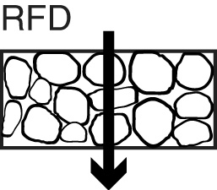
Sediment Basin | SB | 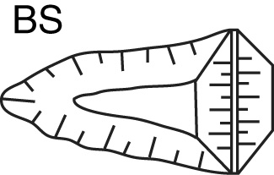 | Sediment Fence – woven fabric | SF | 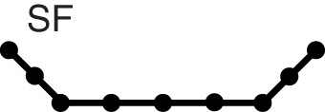
Sediment Trench | SS | 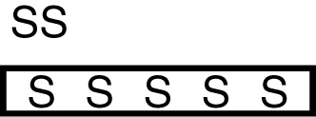 | Sediment Weir | SW | 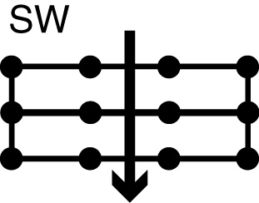
Stiff Grass Barrier | SGB |  | Straw Bale Barrier | SBB | 
U-Shaped Sediment Trap | UST | 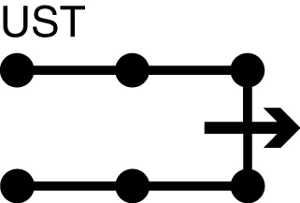

Sediment control – entry/exit control techniques
Technique | Code | Symbol | Technique | Code | Symbol
Construction Exit | Exit | 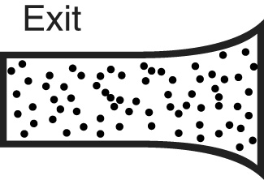 | Rock Pad | Exit
Vibration Grid | Exit | 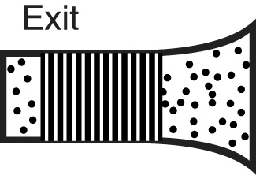 | Wash Bay | Exit | 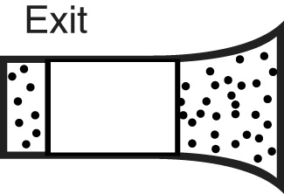

Sediment control – roadside kerb inlet control techniques
Technique | Code | Symbol | Technique | Code | Symbol
Gully Bag | GB | 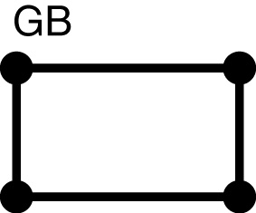 | On-grade Kerb Inlet Sediment Trap | OG | 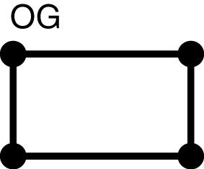
Sag Inlet Sediment Trap | SA | 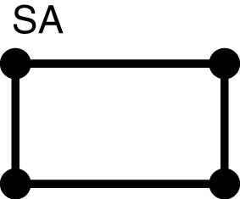

Sediment control – field (drop) inlet control techniques
Technique | Code | Symbol | Technique | Code | Symbol
Block & Aggregate Drop Inlet Protection | BA | 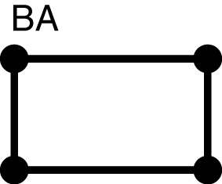 | Excavated Drop Inlet Protection | EX | 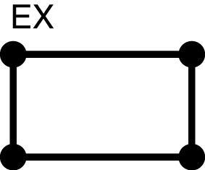
Fabric Drop Inlet Protection | FD | 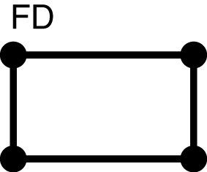 | Fabric Wrap Inlet Protection | FW | 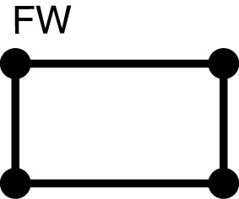
Filter Sock Drop Inlet Protection | FS | 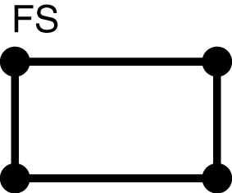 | Gully Bag | GB
Mesh & Aggregate Drop Inlet Protection | MA | 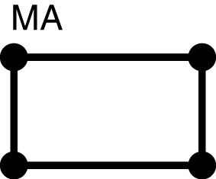 | Rock & Aggregate Drop Inlet Protection | RA | 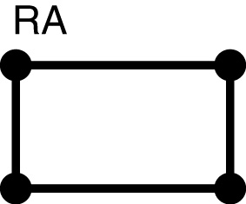

De-watering sediment control techniques
Technique | Code | Symbol | Technique | Code | Symbol
Filter Bag | FB | 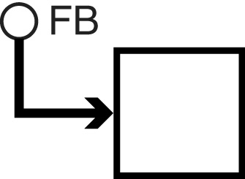 | Filter Fence | FF
Filter Pond | FP | 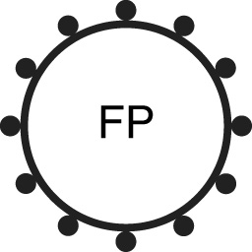 | Filter Tube | FT | 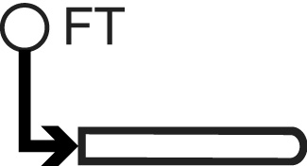
Filter Tube Dam | FTD |  | Grass Filter Bed | GFB | 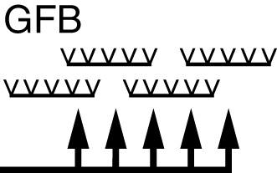
Portable Sediment Tank | PST | 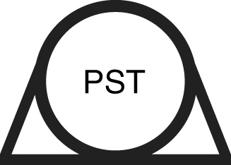 | Settling pond | SEP | 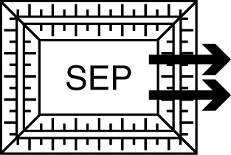
Stilling Pond | STP | 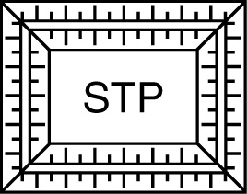 | Sump Pit | SP | 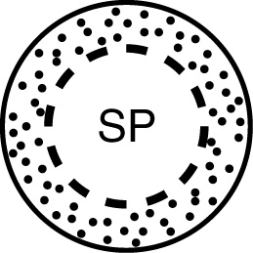

Instream sediment control techniques
Technique | Code | Symbol | Technique | Code | Symbol
Filter Tube Barrier | FTB | 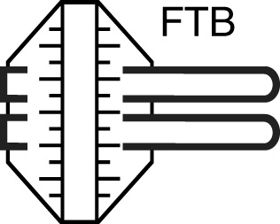 | Modular Sediment Barrier | MSB | 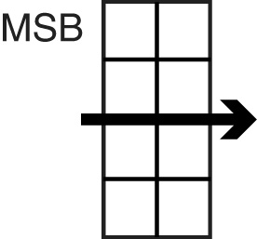
Rock Filter Dam | RFD | 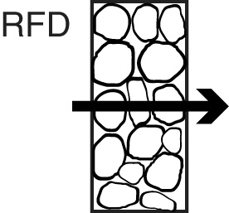 | Sediment Filter cage | SFC | 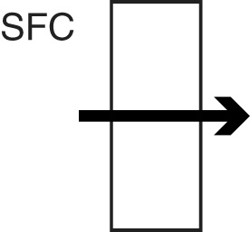
Sediment Weir | SW | 