Erosion and Sediment Control Model Code of Practice

(Building Sites)
This model Code of Practice has been provided as an example of a local government building code for the management of erosion and sediment control on detached-dwelling building sites.

Compliance with a given Performance Criterion can only be achieved by:
- complying with the all items listed as the Acceptable Solution; or
- formulating an alternative solution which complies with the Performance Criterion, or is shown to be at least equivalent to the acceptable solutions; or
- a combination of (i) and (ii).

The Explanatory Notes form part of this model Code of Practice. The Explanatory Notes provide essential information that is otherwise not contained within the Code.

DRAINAGE CONTROL
Performance Criteria |  | Acceptable Solution
P1 | Up-slope stormwater runoff is managed to minimise soil erosion and site wetness. | A1 | - If the area of land up-slope of the soil disturbance exceeds 1500m², then all reasonable and practicable measures are taken to divert this stormwater around the soil disturbance in a manner that does not increase soil erosion or result in the contamination of the diverted water.  - Wherever reasonable and practicable, sandbags, Catch Drains, Flow Diversion Banks or other appropriate drainage systems are used to divert stormwater around excavations and service trenches.  - Wherever reasonable and practicable, flow diversion systems are used to direct up-slope stormwater away from unprotected earth batters steeper than 4:1 (H:V).
P2 | Stormwater runoff does not cause unacceptable levels of soil erosion. | A2 | - Appropriate measures are used to control soil erosion within all temporary and permanent drainage systems (e.g. through the use of channel linings, turfing, or the placement of velocity control Check Dams).  - All stormwater discharges onto a stable surface.
P3 | Stormwater runoff does not cause a nuisance or damage to adjoining properties. | A3 | - Stormwater is discharged in a non-erosive manner at a legal point of discharge.  - Temporary drainage systems immediately up-slope of existing residential properties are designed to a standard commensurate with the risk of nuisance flooding and/or sediment deposition.
P4 | Roof water from within the site does not unreasonably increase soil wetness within the work area. | A4 | - A temporary or permanent roof water drainage system is installed before the roof covering is laid.  - Roof water is discharged through a temporary or permanent roof drainage system to a location that minimises soil erosion and site wetness.

EROSION CONTROL
Performance Criteria |  | Acceptable Solution
P5 | Site activities are carried out in a manner that minimises the duration that disturbed soils are exposed to the erosive forces of wind, rain and flowing water. | A5 | - Soil disturbance is not carried out until the principal on-site activities are ready to commence.  - All reasonable and practicable measures are taken to minimise the removal of, or disturbance to, vegetation and ground covers (organic or inorganic) on the site prior to and during land-disturbing activities.  - All reasonable efforts are taken to coordinate:  - the activities of subcontractors to minimise the duration of soil disturbance; and  - common trenching of utilities.
P6 | Soil erosion resulting from rainfall is minimised. | A6 | - Existing ground covers (grass, mulch, and so on) are protected from damage and retained as long as practicable.  - All reasonable and practicable measures are taken to cover, stabilise or otherwise protect non-vegetated soil surfaces from the erosive effects of rainfall as soon as reasonable and practicable after works on these surfaces have been completed.  - Service trenches are:  - backfilled, compacted and capped with a layer of topsoil to a level at least 75mm above the adjoining ground level; or  - backfilled, compacted and rehabilitated in a manner that best prevents undesirable water flow and soil erosion along the trench.
P7 | Soil erosion resulting from strong winds is minimised. | A7 | Stockpiles of erodible material are covered during periods of strong wind or when strong winds are expected.
P8 | Stormwater is not contaminated by unacceptable levels of sediment resulting from material stockpiles. | A8 | - Stockpiles of erodible material are not located within drainage depressions. Otherwise up-slope stormwater runoff is diverted around these stockpiles in a non-erosive manner.  - Stockpiles of erodible material are covered with a synthetic cover, mulch, or temporary vegetation if not fully used within four (4) weeks.  - Short-term stockpiles of erodible material located outside of the sediment control zone are covered if it is raining; or rain is imminent; or at the end of the working day.
P9 | Exposed soil surfaces are rehabilitated as soon as practicable to prevent or minimise soil erosion. | A9 | All reasonable and practicable steps are taken to:  - incorporate all necessary site rehabilitation measures into the building contract such that these works will be completed before the end of the contracted works; and/or  - coordinate, facilitate and expedite the prompt rehabilitation of finished earthworks with the land owner and/or external contractors.

SEDIMENT CONTROL
Performance Criteria |  | Acceptable Solution
P10 | Adequate precautions are taken to minimise sediment leaving the work area due to site traffic. | A10 | - Vehicle access to the site is limited to stabilise entry/exit points.  - The number of entry/exit points for the site is minimised.  - If vehicular access into, or out of, a site is likely to track sediment onto an external sealed roadway, then a stabilised, sediment control entry/exit system (e.g. Rock Pad, Vibration Grid) is placed adjacent the external roadway.
P11 | Site activities do not allow unacceptable levels of sediment to leave the work area. | A11 | - Soil disturbances are not conducted until the associated Erosion and Sediment Control Plan has been approved.  - No clearing or soil disturbance is undertaken unless preceded or accompanied by installation of adequate drainage and sediment control measures.  - A suitable sediment barrier is placed down-slope of any on-site soil disturbance.  - An appropriate sediment barrier is placed around any on-site stormwater inlet that would otherwise be subject to sediment-laden inflow.  - Sufficient space is provided for the on-site storage of all erodible materials up-slope of a suitable sediment barrier.  - Appropriate additional or alternative ESC measures are undertaken if it is determined that unacceptable off-site sedimentation is occurring.  - Material removed from sediment control devices is disposed of in a manner that does not cause ongoing soil erosion or environmental harm.
P12 | Sediment control measures are located within the property boundary. | A12 | All sediment control measures are located within the property boundary, unless:  - it is that portion of the entry/exit pad located between the property boundary and the sealed road; or  - the sediment control measure is required to collect sediment wash-off from building works located along the property boundary; and  - approval has been obtained from the relevant regulatory authority and the relevant landowner or asset manager.
P13 | Extent and duration of damage and/or disturbance to vegetation contained within the road reserve must be minimised. | A13 | Damage to vegetation contained within the road reserve that is the direct result of the building works, including that resulting from the parking of vehicles or equipment, or the storage of materials, must be:  - minimised in both extent and duration, to that required to carry out necessary building works; and  - stabilised, repaired, or revegetated as soon as reasonable and practicable.

SITE MANAGEMENT
Performance Criteria |  | Acceptable Solution
P14 | Off-site material spills and accumulated sediment deposits are managed in a way that minimises environmental harm, safety issues, and damage to public and private property. | A14 | - Sediment and other material that has originated from the work area, or as a result of the transportation of materials to or from the work area, that collects on sealed roads or within gutters or drains outside the immediate work area, is removed:  - immediately if rain is occurring or imminent; or  - immediately if considered a safety hazard; or  - if items (i) or (ii) do not apply, before completion of the day’s work.  - Sediment, including clay, silt, sand, gravel, soil, mud, cement and ceramic waste, deposited off the site as a direct result of an on-site activity, is collected and the area appropriately cleaned in accordance with (a) above, and in a manner that gives appropriate consideration to the safety and environmental risks associated with the deposited material.  - Washing/flushing of sealed roadways only occurs in circumstances where sweeping has failed to remove sufficient deposited material and the remaining material represents a safety risk. In such circumstances, all reasonable and practicable sediment control measures must be used to prevent, or at least minimise, the release of sediment into receiving waters. Any material collected is disposed of in a lawful manner that does not cause ongoing soil erosion or environmental harm.
P15 | All reasonable and practicable measures are taken to prevent concrete waste from entering gutters, drains and waterways. | A15 | - Solid and liquid waste from concrete trucks and equipment is fully contained on the site.  - Cement residue from work activities is:  - washed onto a pervious surface (e.g. a grassed or open soil area, or excavated trench); or  - filtered through a fine-grained, porous embankment lined with an appropriate filter cloth; or  - collected and disposed of in a manner that does not cause ongoing environmental harm.
P16 | All reasonable and practicable measures must be taken to prevent contaminated water resulting from cutting and cleaning activities entering gutters, drains and waterways. | A16 | - Washing of tools and painting equipment is carried out within the property and over a porous grassed surface or open soil wherever reasonable and practicable.  - The cutting of concrete, or other fine-grained or sediment-producing material, is carried out in a manner that:  - fully contains any contaminated water for later treatment or disposal; or  - appropriately filters any resulting contaminated water through soil or heavy-duty filter cloth prior to its release from the work area.
P17 | Drainage, erosion, and sediment control measures are maintained in proper working order at all times. | A17 | - All temporary ESC measures are maintained in proper working order for:  - the duration of the soil disturbance; or  - the duration of occupation of the site.  - All ESC measures are inspected after rainfall to assess maintenance requirements and their effectiveness.
P18 | Operational safety issues are given due consideration. | A18 | ESC measures are installed and/or operated in a manner that does not cause a safety risk to the public or site personnel.

PLAN PREPARATION
Performance Criteria |  | Acceptable Solution
P19 | For high-risk sites, an Erosion and Sediment Control Plan (ESCP) is prepared prior to site disturbance that provides sufficient information on proposed measures to control stormwater drainage, soil erosion, and sediment runoff, in sufficient detail and clarity, to achieve the required environmental protection, soil management, and timely installation of proposed measures. | A19 | An ESCP is prepared including plan(s) no larger than 1:1000 that can be readily understood and applied on-site. The ESCP contains the following information where applicable:  - North point and plan scale.  - Site and easement boundaries.  - Proposed building works and limits of disturbance.  - Site access points.  - Location of stockpiles.  - Retained vegetation including protected trees.  - Existing and final site contours.  - Location of all drainage, erosion and sediment control measures.  - Site revegetation requirements (if part of building contract).  - Technical notes on ESC measures, installation sequence and maintenance requirements.  - Any other information about the ESCP or the site that is considered necessary in order for the satisfactory application of the Plan.
P20 | The ESCP is appropriate for the site conditions. | A20 | - The standard of the control measures are commensurate with the degree of environmental risk associated with the proposed works, and the type, cost, and scope of the proposed works.  - The level of detail supplied in the ESCP is commensurate with the complexity of the proposal.

Explanatory notes for Model Code of Practice
Performance Criterion P1
One of the best ways of controlling sediment runoff is to prevent, or at least minimise, soil erosion in the first place. One of the best ways of minimising soil erosion is to appropriately control the flow of stormwater across a building site.

The intent of this Performance Criterion is to minimise the risk of stormwater runoff (either originating from the site or from up-slope properties) causing the following problems:
- soil erosion caused by “sheet” or “concentrated” stormwater runoff;
- soil erosion caused by stormwater spilling down unstable earth batters;
- increased site wetness (i.e. the generation of saturated soil and/or mud);
- excessive quantities of stormwater runoff either overloading, or causing structural damage to, down-slope sediment barriers such as a Sediment Fence.

Acceptable Solution A1(a)
The diversion of stormwater runoff around a soil disturbance is always beneficial, unless of course, rainfall is unlikely to occur during the building works.

For the purpose of this Code it has been assessed that a catchment area of 1500m² is likely to produce sufficient quantities of stormwater runoff to warrant the use of a flow diversion system. Local authorities may vary this catchment area based on local hydrological conditions.

Some local authorities may consider that flow diversion is usually only justified during periods of actual rainfall, or during those months when the average monthly rainfall is medium or higher (i.e. greater than 45mm). In such a case the Solution may be stated as:

If the area of land up-slope of the soil disturbance exceeds 1500m², then during those months when the rainfall is expected to exceed 45mm, all reasonable and practicable measures are taken to divert this stormwater around the soil disturbance in a manner that does not increase soil erosion or result in the contamination of the diverted water.

Acceptable Solution A1(b)
Minimising the quantity of water entering excavations and trenches will reduce site wetness and the quantity of sediment-laden water that needs to be pumped/drained from these trenches to allow works to continue.

Acceptable Solution A1(c)
Unprotected earth batters can be highly susceptible to soil erosion, including “rilling”, if exposed to excessive stormwater flows. Earth batters that expose dispersive soil can also be susceptible to gully erosion and/or structural failure.

Earth batters may be protected with the use of: vegetation, mulch (small batters), Erosion Control Blankets, rock or structural retaining walls. Earth batters that expose dispersive soil should always be protected with a layer (minimum 100mm) of non-dispersive soil before placement of the final batter stabilisation.

Performance Criterion P2
Unacceptable levels of soil erosion include, but are not restricted to, the following examples:
- soil erosion caused by “sheet” flow that results in the loss of the equivalent of more than 10mm of soil from an area greater than 1m²;
- soil erosion that results in clearly visible “rilling” or channelling within the soil, or rill erosion to a depth greater than 100mm;
- the displacement of more than 10% of the erosion-control mulch placed over previously disturbed soil.

Acceptable Solution A2(a)
Stormwater runoff across the property must be managed in a non-erosive manner. This will require one or more of the following:
- stormwater runoff is diverted around disturbed soil;
- flow velocities are controlled to avoid soil erosion;
- drainage surfaces are lined with a material (i.e. turf, erosion control mats, filter cloth, or sediment fence fabric) that prevents erosion of the underlying soil;
- water is transported within suitably sized drainage pipes.

In some cases, flow velocities in open channels can be controlled by installing a series of small Check Dams (Figure 1). These Check Dams are usually constructed from sand or gravel-filled bags. In deep channels (> 500mm deep), Rock Check Dams can be used. It is important to ensure these Check Dams do not cause flow to be diverted from the channel.

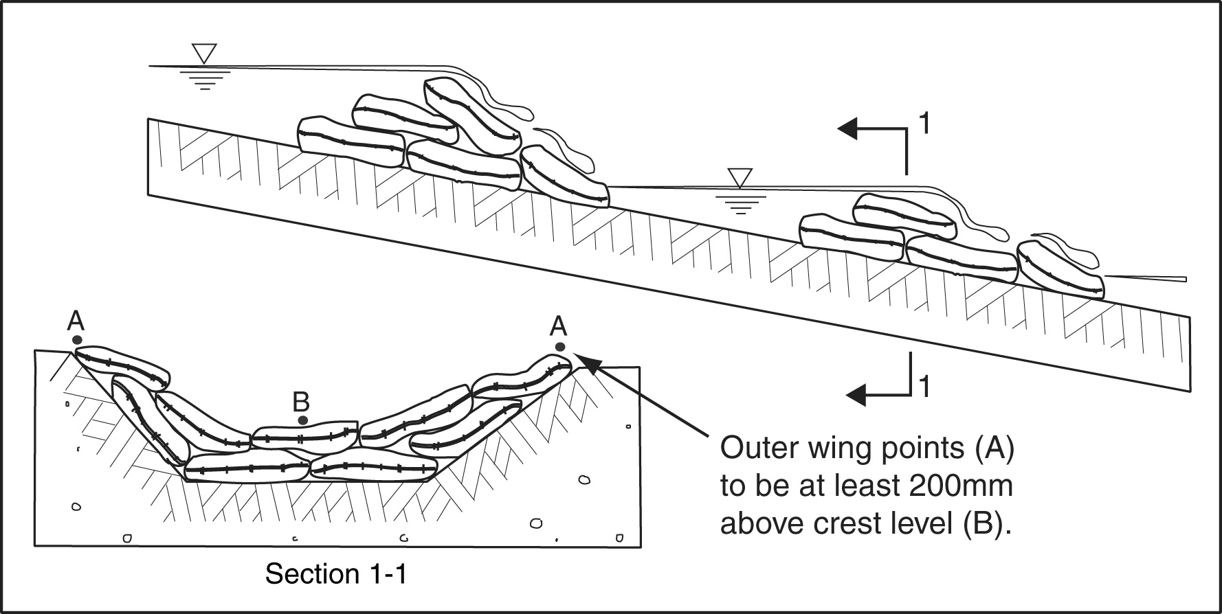
Figure 1 – Sandbag Check Dams

Acceptable Solution A2(b)
Diverted stormwater must not be allowed to cause unacceptable soil erosion upon its release from a drainage channel, Chute or stormwater pipe. In these circumstances, “unacceptable soil erosion” would mean any obvious form of soil erosion.

Performance Criterion P3
Diverted water must not be directed onto an adjacent property or be allowed to cause a nuisance within an adjoining, or any other downstream property. Some local authorities may accept water being temporarily diverted onto an adjoining property if that property is owned by, and in the control of, the same landowner or builder of the property from where the water was diverted.

Acceptable Solution A3(a)
If the water already flows into the adjoining property and this is considered to be its natural direction of flow, then before it reaches the property boundary, any diverted water must be returned to its original flow conditions in terms of velocity, quantity and direction.

If the adjoining property is owned and controlled by the same builder/owner, then a proposal to divert water into the adjoining property must be addressed in consultation with the appropriate authority. Stormwater must only discharge at a legal point of discharge.

Acceptable Solution A3(b)
The size and stability of a flow diversion system must take appropriate consideration of the expected flow rate, the risk of nuisance flooding to the downstream property, and the likely nuisance that sediment deposition would have on the downstream property.

The design storm standard would likely be between the 1 in 1 year to 1 in 10 year ARI design storm in accordance with the requirements of the regulatory authority.

Performance Criterion P4
Stormwater runoff from roofs and other impervious surfaces can unnecessarily disturb the work site and increase the potential for the site to cause environmental harm. Failing to adequately manage roof water can cause the following problems:
- decrease the efficiency of on-site sediment control devices by increasing the volume of water required to be treated by these devices;
- increase the likelihood that sediment control devices will fail during periods of high rainfall;
- increase soil erosion, especially near the outlets of downpipes;
- increase the generation of mud through increased site wetness, thus increasing the transportation of clay-sized particles from the site;
- increase building delays and decrease site safety through increased frequency and duration of soil saturation within the work area;
- increase soil erosion within or along service trenches.

Acceptable Solution A4(a)
Due to the relative size of the roof to the average urban property, the immediate connection of roof water downpipes to the permanent, underground, stormwater drainage system is arguably the most financially beneficial soil erosion and sediment control measure on building sites.

In some regions of Australia there may be no requirements for the construction of a sub-surface, roof water drainage system. In such cases, all reasonable efforts should be taken to install a temporary above ground drainage pipe that will direct roof water away from disturbed soil and the work area, at least during those months that have an average monthly rainfall greater 45mm.

If the permanent drainage system incorporates sub-surface drainage pipes from the building to the road reserve, or other legal point of discharge, then this drainage system should be installed prior to the roofing system being laid.

Acceptable Solution A4(b)
During those months when the average monthly rainfall exceeds 45mm, the roof water drainage system should be connected to either a surface or sub-surface, erosion-resistant drainage system (i.e. pipe) immediately after the roof and guttering is laid. This connection may either be through the use of temporary pipes (Figure 2) or permanent downpipes.  The use of temporary downpipe connections allows for the removal of these pipes during working hours to minimise disruption to building activities. However, these temporary downpipes must be reconnected if rain is occurring, or at the end of the day’s work if rain is imminent or likely to occur after work hours. | 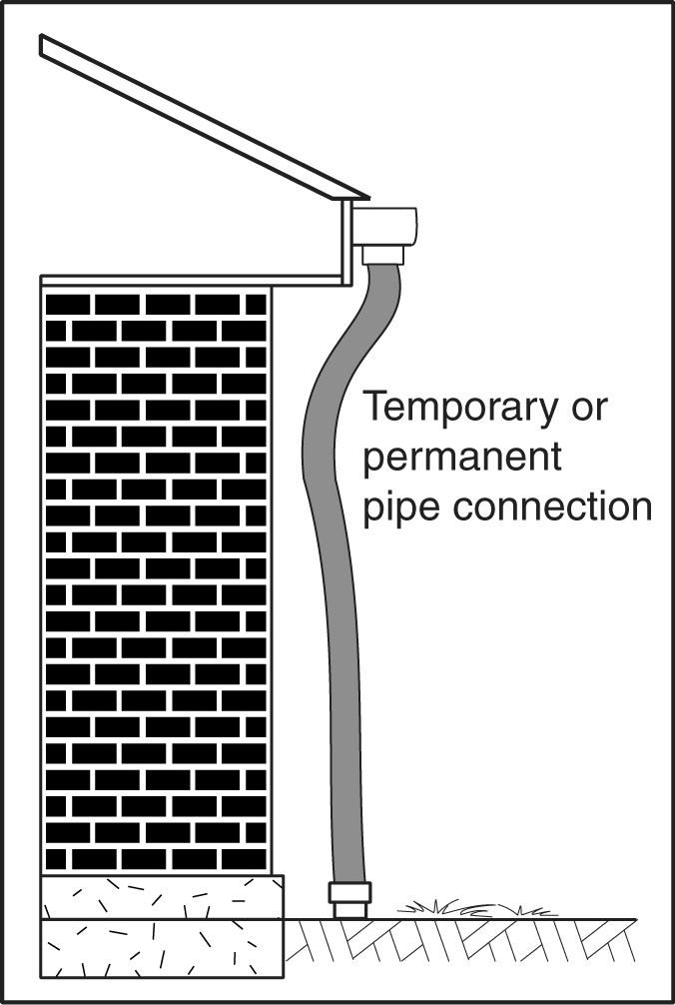  Figure 2 – Temporary downpipe

Performance Criterion P5
It is important to recognise that Erosion Control and Sediment Control are two very different activities. Erosion control measures aim to prevent soil erosion, whereas sediment control measures aim to trap sediment released by some up-slope erosion process.

There are virtually no sediment control measures that can trap all forms of sediment during all storm events. Specifically, there are very few sediment control measures that successfully trap clay-sized particles (grain size <0.002mm).

Due to the inadequacy of sediment control measures to prevent the discharge of clay-sized particles from a building site, it is important to minimise the initial erosion of clayey soils. One of the most effective forms of erosion control is the principle of minimising soil disturbance.

The most important principle of minimising soil disturbance is to minimise the duration that soils are exposed to the erosive forces of wind, rain and flowing water.

Acceptable Solution A5(a)
All reasonable and practicable measures must be taken to minimise the time between the initial disturbance of soil on the site, and the commencement of building works.

Acceptable Solution A5(b)
Even if the entire site will eventually be disturbed at some stage, all reasonable efforts should be taken to minimise disturbance to any ground cover whether it is grass, mulch, leaf litter, or gravel, and to delay any required disturbance as long as practicable.

Acceptable Solution A5(c)
Soil disturbance resulting from the excavation of service trenches can result in significant sediment runoff. Minimising the number of service trenches and the duration these trenches are exposed can help reduce soil erosion and sediment runoff.

Performance Criterion P6
Almost any form of rainfall-induced soil erosion will release fine-grained, clayey particles that can readily pass through most sediment traps/barriers. Therefore, all reasonable and practicable measures must be taken to minimise unnecessary soil erosion.

Unnecessary soil erosion means erosion resulting from:
- unnecessary site disturbance; or
- unnecessary delays in site stabilisation or rehabilitation; or
- unnecessary exposure of dispersive soils; or
- concentrated stormwater flowing over unprotected soils.

Acceptable Solution A6(a)
The disturbance to any forms of existing ground cover (including, grasses, gravel, and mulch) should be minimised in order to minimise the exposure of soils to rainfall. In addition, any necessary disturbance to these existing ground covers should be delayed as long as practicable.

Acceptable Solution A6(b)
Appropriate erosion protection may be influenced by the following factors:
- slope of land;
- length of slope;
- expected weather conditions;
- erodible nature of the exposed soil;
- depth of soil to bedrock;
- type and availability of local vegetation;
- area of exposed soil;
- cost effectiveness and financial limitations.

On building sites located upstream of critical waterway habitats, all disturbed areas outside the footprint of the base slab (if used, otherwise all disturbed areas) should be mulched (minimum 50mm) or otherwise stabilised against erosion immediately following the completion of bulk earthworks.

An example of possible erosion protection on slopes steeper than 10:1 (H:V) for various expected rainfall conditions is provided in Table 1.

Table 1 – Possible erosion protection measures
Expected rainfall conditions | Possible erosion control measures
Extreme rainfall (e.g. months with an average rainfall greater than 225mm) | - Well-anchored (e.g. pegged) turf.  - Erosion control blankets placed over seeded topsoil and/or planted with trees and shrubs on small areas of land.  - High strength (e.g. reinforced) Erosion Control Blankets placed over seeded topsoil and/or planted with trees and/or shrubs on large areas.
High rainfall (e.g. months with an average rainfall of 100 to 225mm) | - Appropriately anchored (e.g. pegged) turf.  - Erosion Control Blankets placed over seeded topsoil and/or planted with trees and/or shrubs.
Low to moderate rainfall (e.g. months with an average rainfall less than 100mm) | - Heavy mulching planted with trees and/or shrubs.  - Light mulching placed over grass-seeded topsoil.  - Any option listed for the above categories.

Acceptable Solution A6(c)(i)
If a backfilled trench is not compacted to a firm condition, then soil settlement can occur over time or after significant rainfall. This lack of compaction can lead to the formation of a drainage depression along the trench resulting in the concentration of stormwater runoff and possible soil erosion.

Backfilling the trench to a level at least 75mm above the adjoining ground level will usually address any future soil settlement (even if appropriate initial compaction is achieved). Variations of this requirement exist in different regions, thus always seek advice from the regulatory authority.

Acceptable Solution A6(c)(ii)
An alternative to A6(c)(i) would be to rehabilitate service trenches in a manner that has proven in the past to prevent unacceptable soil erosion or sediment runoff.

Performance Criterion P7
Wind erosion is typically a problem in coastal regions that have sandy soils. Strong winds are winds of sufficient velocity to erode the exposed soil or stockpiled material.

Acceptable Solution A7
Stockpiles most likely to be affected by strong winds are stockpiles of sandy soils located in coastal regions. Areas likely to be affected by strong winds may be identified by the regulatory authority.

Erosion from these stockpiles can be reduced by covering the stockpile with plastic sheeting, Erosion Control Blankets, mulch (light or heavy mulching), or temporary vegetation.

Performance Criterion P8
Stockpiles of erodible material such as soil, sand and mulch can be a major source of pollution. Proposed stockpile management techniques must address the following factors:
- type of material;
- expected duration of storage prior to its use;
- alternative storage arrangements and/or locations;
- the movement of concentrated stormwater runoff through the building site;
- practicability of covering the stockpile (to protect material from raindrop impact);
- likelihood and intensity of rainfall;
- expected environmental harm likely to be caused by the displacement of material.

Acceptable Solution A8(a)
Stockpiles of erodible material should not be placed in a location where up-slope stormwater runoff will likely cause the material to be washed away.

The sediment control zone is defined as that portion of a building site that drains to a sediment control device, excluding the entry/exit pad.

Acceptable Solution A8(b)
Protective cover may include plastic sheeting, filter cloth or Erosion Control Blankets. Organic covers such as mulch may be appropriate during periods of low wind. Temporary vegetation is only appropriate for very long-term stockpiles. Clayey material should ideally be covered with an impervious cover to reduce rainwater infiltration into the material.

Synthetic stockpile covers, such as plastic sheeting, may not be practical if regular loss/theft of these covers from the building site places an unreasonable financial burden on the builder.

Acceptable Solution A8(c)
In some circumstances it is not practical to temporarily store some materials in an area protected by a sediment barrier. A short-term stockpile means a stockpile that is located on-site or off-site for less than 24 hours.

Building materials that could reasonably be expected to be removed from the property or storage site by wind, rainfall, or other water may be temporarily stored on hard surfaces in the following circumstances:
- where it is necessary to place erodible material on a hard surface (e.g. a road or driveway) to undertake work and no other reasonable options are available (e.g. placing the material on a nearby grassed area or in a mini-skip); and/or
- the material is stockpiled for less than 24 hours.

In such cases, the material must be:
- removed immediately if rainfall or strong winds are imminent or occurring; otherwise
- removed by the end of the day’s work even if rainfall or strong winds are neither imminent nor occurring.

Such materials must not be stored on a road reserve without obtaining permission from the road authority, usually the regulatory authority. Material placed on the road reserve must not block traffic, or cause safety or environmental problems.

If erodible materials are to be temporarily stored within a road reserve, then a suitable waterproof cover must be available on the site for use in the event of rain. Upon removal of the stockpiled material from the road reserve, the area must be appropriately cleaned (swept), stabilised, and rehabilitated.

Performance Criterion P9
Rehabilitation, in particular revegetation, of a site is one of the most effective ways of minimising long-term soil erosion and environmental harm. Vegetation can significantly reduce raindrop impact erosion, thus reducing runoff turbidity. Note, however, some forms of revegetation (e.g. grass seeding) do not provide effective erosion control during the plant establishment phase unless incorporated with appropriate Mulching or Erosion Control Blankets. To be effective, at least 70% of the soil surface must be protected from raindrop impact.

Turfing is one of the most effective means of providing instant erosion control to a finished soil surface.

Acceptable Solution A9
The appropriate rehabilitation of a site depends on the many factors, including:
- local soil and weather conditions;
- condition and type of vegetation usually expected within the local area;
- expected long-term use of the land;
- financial considerations.

During periods of actual or expected heavy rainfall (i.e. expected monthly rainfall is greater than 100mm), it can be highly beneficial for proposed grassed areas to be turfed rather than grass seeded. Future garden beds can be mulched (e.g. heavy mulching, i.e. greater than 50mm depth).

During periods of extreme rainfall (i.e. actual or expected monthly rainfall is greater than 225mm), Erosion Control Blankets may need to be used on steep sites and in areas of concentrated stormwater runoff.

The higher the expected rainfall intensity, the greater the need to expedite the rehabilitation processes.

Straw mulch (light mulching) can be spread over grass-seeded areas to control soil erosion while the grass is being established. This mulch can also benefit rehabilitation by reducing watering requirements and increasing seed germination.

In those location where turfing is an appropriate means of site rehabilitation, it should be actively promoted, especially during periods of high to extreme rainfall (i.e. expected monthly rainfall is greater than 100mm).

Performance Criterion P10
Sediment deposited on public roads can create a traffic safety hazard as well as being washed into downstream water bodies. Thus all reasonable and practicable measures need to be taken to minimise the quantity of sediment leaving the site at entry/exit points.

It is noted that a stabilised entry/exit rock pad would have questionable value if access to the building site is via an unsealed (i.e. erodible) public road. Therefore, this Performance Criterion may not need to be satisfied if site access is via an unsealed public road—refer to the relevant regulatory authority for advice.

Acceptable Solution A10(a)
All reasonable efforts should be taken to promote site access only via a stabilised access point that satisfies A10(c). In most cases, the placement of a Sediment Fence along the front of the property will promote site access via the stabilised entry/exit point.

Where practicable, heavy machinery such as bobcats, backhoes, and concrete trucks should always access the site via an entry/exit pad.

Acceptable Solution A10(b)
Minimising the number of entry/exit points will reduce the potential for environmental harm.

Acceptable Solution A10(c)
The type of stabilised entry/exit system depends on the site’s soil properties and the drainage conditions of the site (i.e. whether stormwater runoff from the entry/exit pad flows into or away from the property).

Stabilised rock entry/exit pads for small, single-dwelling building sites typically consist of a 150to 200mm deep, 2m wide pad containing 40mm (minimum) to 75mm crushed rock (Figure 3). Where practicable, the stabilised rock pad should extend from the road to the building, but for a distance of at least 10m. Where necessary, 20mm aggregate should be placed over the crushed rock between the property boundary and the sealed road to make the rock pad safe for pedestrian traffic.

Stabilised crushed rock entry/exit pads can be used on both sandy and clay-based soils.

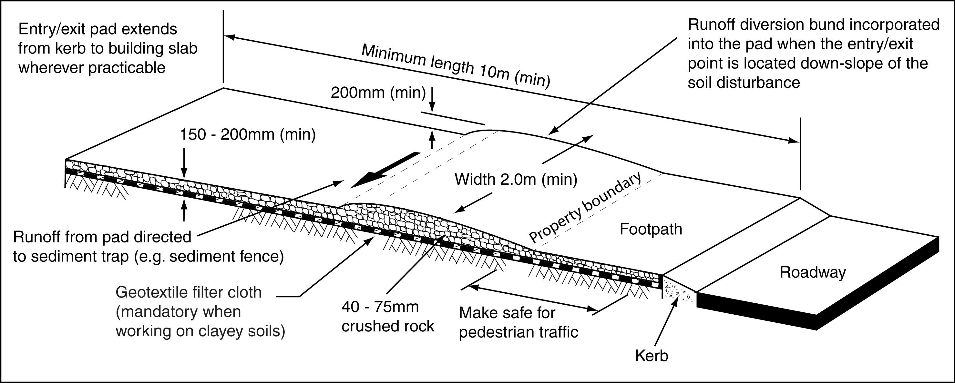

Figure 3 – Stabilised rock entry/exit pad for building sites (not construction sites)

On sites containing sandy soils, a prefabricated Vibration Grid (i.e. cattle grid) can be used to shake sand from vehicles. However, a gravel or aggregate pad must exist between the Vibration Grid and the road. The length of the Vibration Grid should be sufficient to remove loose sediment from vehicles. A minimum length of 3.5m is recommended. A Vibration Grid must not be located within the road reserve.

The environmental benefits of a stabilised entry/exit pad can be greatly diminished if sediment trapped on the pad is allowed to wash from the site during storm events. This problem typically occurs on building sites that are above road level.

Placing a minimum 200mm high flow diversion bund diagonally across the top of the entry/exit pad can deflect stormwater across the pad and into a suitable sediment trap. This sediment trap may consist of the main Sediment Fence, or a separate, U-shaped Sediment Trap.

Performance Criterion P11
There are two forms of sediment that can cause harm to the environment, fine sediment and coarse sediment. Fine, clay-sized particles may be controlled using good site drainage and erosion control techniques and by promptly rehabilitating all disturbances. Coarse sediment is usually controlled through the use of sediment control measures.

All reasonable and practicable measures must be taken to minimise the total volume of sediment leaving the work site.

Unacceptable levels of soil and sediment runoff means:
- Any quantity of soil or sediment that may cause harm to the environment taking into consideration the cumulative effects of other building and construction activities within the drainage catchment.
- Any quantity of soil or sediment runoff from the site that results in the accumulation of more than 500g of soil or sediment within any 1m² area outside the property. This quantity of loose, coarse sediment represents approximately two, 70mm diameter balls of dry sediment, within any 1m².

Acceptable Solution A11(a)
Where an Erosion and Sediment Control Plan is required by a regulatory authority for the building works, then this plan must be approved by the regulatory authority prior to any site disturbance.

Acceptable Solution A11(b)
In most circumstances all necessary up-slope drainage controls and down-slope sediment controls should be installed prior to commencing any soil disturbance including land clearing. The exceptions are:
- land clearing and soil disturbance required to allow access to, and installation of, the various drainage and sediment control measures;
- works conducted during an initial period when rainfall is highly unlikely and thus there is no measurable risk of contributing to environmental harm.

Sediment barriers may be removed or lowered to allow site access and building operations, but the barrier must be ready for immediate reinstallation in the case of rain, and the barrier must also be fully operational at the end of each day’s work.

Acceptable Solution A11(c)
Sediment barriers are usually placed along the property boundary immediately down-slope of the soil disturbance. Where conditions allow, the barrier should be placed along a line of constant elevation to avoid the barrier concentrating or diverting stormwater runoff.

On most building sites, the most appropriate sediment barrier is a Sediment Fence formed from purpose-made fabric (Figure 4). Filter cloth or shade cloth must NOT be used.

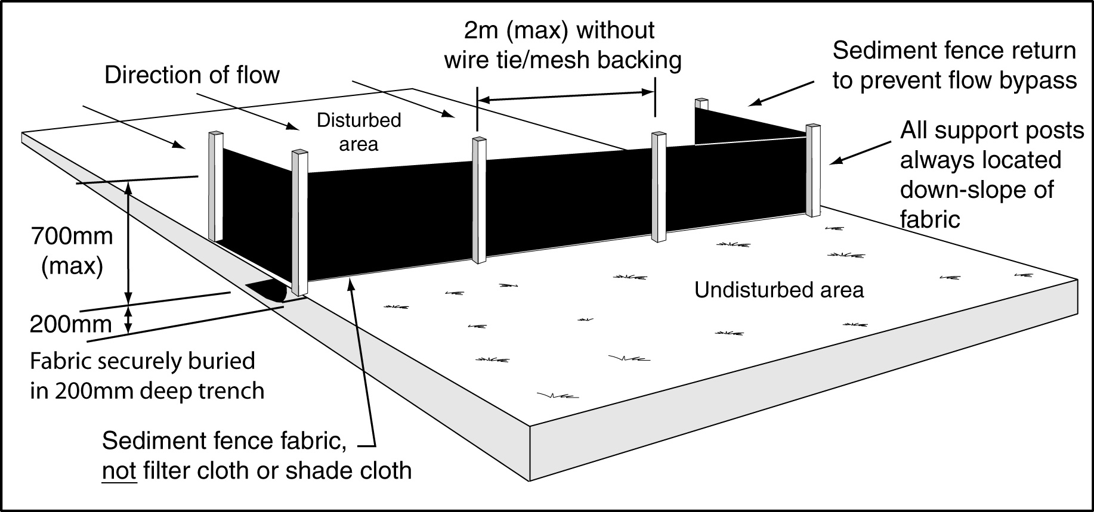
Figure 4 – Installation of a Sediment Fence

Sediment fence fabric should be manufactured from a woven UV-stabilised geotextile or non-woven geotextile reinforced with a UV-stabilised polypropylene mesh. The geotextile fabrics are to be either polyester or polypropylene manufactured to the requirements specified in Table 2.

Table 2 - Sediment Fence material property requirements
Property | Test Method | Units | Typical Value
Flow rate | AS 3706.9 | L/s/m²  (under 100 mm head) | 145
Wide strip tensile strength | AS 3706.2 | kN/m | 17  both directions
Pore size (EOS) (O₉₅) | AS 3706.7 | μm | 110
Mass per unit area | AS 3706.1 | gsm | 225

Stakes should consist of 1250mm² (cross section) hardwood, or 1.5kg/m (minimum) steel star pickets suitable for attaching fabric.

Acceptable Solution A11(d)
An appropriate sediment barrier should be installed around any on-site stormwater inlet to minimise the release of sediment from the property.

Appropriate sediment barriers include heavy-duty filter cloth or Sediment Fence fabric wrapped around the grate, or a vertical Sediment Fence constructed around the inlet.

Acceptable Solution A11(e)
Building works should not be approved unless it can be demonstrated that there is sufficient room within the property, and within the sediment control zone, to locate all necessary long-term stockpiles of erodible material.

Where necessary, stockpile areas should be clearly identified to prevent materials being delivered to the wrong location.

The sediment control zone is defined as that portion of a building site that drains to a sediment control device, excluding the entry/exit pad.

Acceptable Solution A11(f)
If the adopted erosion and sediment control measures fail to prevent unacceptable levels of off-site sedimentation, then additional measures will be required unless such measures would be considered unreasonable or impracticable.

Acceptable Solution A11(g)
Sediment removed from a sediment control barrier should either be integrated with on-site soils, or removed from the site. In either case, the sediment should not be placed in a position, or in a manner, that would likely result in the sediment being washed or blown from the site, or washed into an external gutter, drain, or water body.

Performance Criterion P12
Wherever reasonable and practicable, all ESC measures should be fully located within the property; however, it must be acknowledged that part of a stabilised entry/exit pad must extend outside the property boundary.

Acceptable Solution A12
No sediment control measure should be located outside the property boundary, unless:
- that control measure includes that portion of the entry/exit pad located between the property boundary and the sealed road; or
- the sediment control measure is required to collect sediment wash-off from building works located along the property boundary (such as the construction of a front retaining wall); and
- regulatory authority permission has been obtained for the location of the sediment control measure outside the property.

Performance Criterion P13
One of the best ways of controlling sediment runoff is to prevent, or at least minimise, soil erosion in the first place. One of the best ways of minimising soil erosion is to minimise the disturbance to existing ground covers, including the grassed pedestrian area (verge) located within the road reserve.

Acceptable Solution A13
The road reserve is considered a public asset and as such damage to this public asset, including any vegetation, should only occur if there are no other reasonable options available to carry out the necessary building works.

If vegetation damage does occur within the road reserve, and if this damage could result in soil erosion, then all reasonable and practicable measures should be taken to minimise the extent and duration of this erosion hazard, including prompt stabilisation, repair or revegetation of the area.

Performance Criterion P14
Material spills and sediment deposits located outside the sediment control zone have a higher risk of causing a safety hazard or being washed into a gutter, drain or water body. Such material spills and sediment deposits must be cleared from the area within a reasonable time frame and in an appropriate manner, based on the assessed safety and environmental risks.

Acceptable Solution A14
Some material spills located outside the property boundaries may be beyond the reasonable control of the builder or property owner; however, if these deposits are directly associated with the building activities (e.g. resulting from the delivery of materials), then all reasonable and practicable measures must be taken to minimise both the safety risk and potential environmental harm.

Reasonable and practicable measures may include:
- providing appropriate delivery instructions;
- providing adequate and appropriate space for the delivery of materials;
- providing a stabilised access pathway for the delivery of materials;
- actively investigating alternative delivery methods or material suppliers if regular pollution problems occur;
- assisting in the prompt removal of sediment deposits and material spills.

To clean materials from hard surfaces, the bulk of the material should first be shovelled, then swept onto an area enclosed by a suitable sediment barrier (i.e. up-slope of a Sediment Fence). An acceptable procedure for cleaning the remainder of the material from the surface is detailed below in order of priority.
- Use a vacuum unit (e.g. hired street sweeper), where the cost can be justified.
- Manually sweep the material onto an adjacent grassed or open soil surface where sediment controls are in place (e.g. up-slope of a Sediment Fence).
- If a safety hazard may result from the remaining material being left on the hard surface, then, and only then, hose the remaining material onto a grassed surface or into a temporary filter dam constructed in the gutter. After allowing the excess water to drain from the dam, the retained material must be collected and disposed of in a location where it would not be expected to wash off into a gutter, drain or water body.

The above recommendations are based on the principle that less environmental harm will be caused if small amounts of sediment are removed from a sealed road by stormwater runoff rather than by manually washing the road during dry weather.

Performance Criterion P15
Cement and concrete residue can increase water turbidity, alter water pH, and adversely affect the hydraulic capacity of drainage pipes. Typically, state authorities will have legislative requirements regarding the acceptable pH range for site discharges (e.g. 6.5 to 8.5).

Acceptable Solution A15(a)
Cement and concrete residue from concrete trucks or on-site mixers must not be allowed to enter drains or waterways. Excess concrete should be stockpiled on-site for later disposal.

Acceptable Solution A15(b)
Approval should not be given to a proposed concrete surfacing technique if the proponents fail to demonstrate how the proposed surfacing technique will be prepared without causing undue environmental harm.

Where appropriate, the options provided in Acceptable Solution A16 may be used to minimise the potential environmental harm caused by cement/concrete residue.

Any construction technique that would not cause environmental harm, or the release of cement, concrete or contaminated water into a stormwater pipe or water body, would satisfy this Performance Criterion.

Performance Criterion P16
Waste water generated by water-cooled cutting activities and the cleaning of equipment usually contains large quantities of fine-grained sediments that can readily pass through most sediment control devices. Therefore, a sediment control barrier cannot be relied upon to minimise the potential environmental harm caused by these building activities.

On some building sites it may not be practicable to prevent all forms of pollution generated by such activities from leaving the site; however, all reasonable and practicable measures must still be taken to minimise any potential harm.

Acceptable Solution A16(a)
The first priority should always be to conduct all cutting and cleaning activities within the property and specifically within the sediment control zone.

When porous grassed or open soil areas are available, then all mobile, pollution-generating activities should be conducted within these areas to minimise the release of pollutants from the site. If the soil becomes saturated, thus significantly limiting further infiltration of water, then the activity should be relocated, or an alternative pollution control technique should be used.

In some cases it may be beneficial to place filter cloth over the soil before commencing the cutting or cleaning activity.

Acceptable Solution A16(b)(i)
The waste water may be fully contained in an excavated pit and allowed to infiltrate the soil, or pumped from the pit to a mini-skip, or to a Filter Bag for treatment.

Acceptable Solution A16(b)(ii)
Some heavy clay soils allow little or no infiltration of water. In such cases, all reasonable and practicable steps should be taken to filter the polluted water through a temporary, porous bank formed from fine-grained material, such as fine sand. The bank must have sufficient width/depth to significantly reduce the turbidity of the polluted water.

The efficiency of the filter bank can be improved by placing heavy-duty filter cloth over the upstream face of the bank and/or placing filter cloth under the pollution-generating activity.

Performance Criterion P17
Proper working order means the control devices are operating in an efficient manner that is consistent with intended function of the device, and in a manner that prevents or minimises potential or actual environment harm.

Efficient manner means the control device is functioning in a manner that will:
- intercept the maximum quantity of polluted water (within the structural capabilities of the device); and
- trap the maximum quantity of pollutants; and
- contain trapped pollutants for sufficient time to allow for their appropriate removal.

Acceptable Solution A17(a)
Maintaining ESC measures in “proper working order” means taking all reasonable and practicable measures to sustain all ESC measures in such a condition that:
- will best achieve the site’s required environmental protection, including any specified water quality objectives for all discharged water (principle objective); and
- is in accordance with the specified operational standard for each ESC measure; and
- prevents or minimises safety risks.

A soil disturbance may be considered to exist up until a minimum 70% coverage (vegetative, organic or inorganic) is achieved over all soils disturbed (directly or indirectly) as a result of the building activities.

A minimum 70% coverage does not mean that a minimum of 70% of the site is protected from erosion. Rather it means that all areas of erodible soil on the site have at least 70% coverage of vegetation, mulch or other suitable material to prevent raindrop impact on the soil and erosion by flowing water. As such, 70% coverage is measured by looking vertically down on the soil, and applies to any and all disturbed areas of the building site.

Acceptable Solution A17(b)
All reasonable and practicable measures must be taken to minimise regular structural failures and to facilitate the immediate repair of necessary control measures. Measures may include:
- storing on-site, or within the immediate area, sufficient Sediment Fence fabric to facilitate necessary repairs;
- modifying damaged control measures to reduce the potential for ongoing failure;
- modify on-site drainage patterns to reduce the risk of ongoing damage to ESC measures;
- install additional and/or alternative ESC measures to minimise the risk of ongoing failure.

Repairs should be sufficient to re-establish the required efficiency of the ESC measure.

Performance Criterion P18
The safety of the public and all site personnel is a high priority.

Acceptable Solution A18
Appropriate consideration should be given to potential safety risks associated with a proposed erosion and sediment control measure. Any ESC measure should not be installed if it represents an unacceptable safety risk. In such cases, suitable alternative ESC measures must be employed.

Performance Criterion P19
High-risk sites may be identified through the use of an appropriate Erosion Hazard Assessment of the site. Land disturbance on sites steeper than 20% may not always be classified as high-risk sites; however, due to the difficulties of working on such sites, it is recommended that they be included within this Performance Criterion. A regulatory authority may exempt a site from the need to submit an Erosion and Sediment Control Plan (ESCP).

It is noted that one or more plans may be required to adequately describe the proposed erosion and sediment control measures, or to describe the various building stages or drainage conditions that will exist on the work site during the building phase.

Building works assessed as low-risk sites are still required to take all reasonable and practicable measures to minimise environmental harm caused by on-site soil erosion and sediment runoff. On low-risk sites, an ESCP may still need to be prepared to convey to site personnel the proposed erosion and sediment control measures, but this plan does not need to be approved unless specifically requested by the regulatory authority.

Low-risk sites will still need to satisfy Performance Criteria P1 to P18.

Acceptable Solution A19
A plan scale of preferably 1:200, 1:250 or 1:500 is recommended, but not larger than 1:1000.

Identifying existing and final contours allows regulators to appreciate the extent of earthworks involved in the building proposal. If major earthworks are to be staged, and if these earthworks affect stormwater drainage patterns, then more than one ESCP may be required to adequately describe the proposed soil erosion and sediment control measures (i.e. one ESCP prepared for each stage of earthworks).

Identifying the proposed building works assists regulators to assess the minimum required limits of disturbance.

Identifying the limits of site clearing allows regulators to determine the extent and likely duration of soil exposure.

In rural areas, often the only sediment control measure required around a building site is the extensive grassed areas that surround the building site. If such areas are to be used as a sediment barrier, then the ESCP should indicate that these areas will remain largely undisturbed.

A stabilised site entry/exit point should form part of the site’s sediment control measures, and therefore should be shown on the ESCP. If separate site entry and exit points are required, then this should also be indicated on the plan.

Stockpile locations need to be shown to demonstrate:
- adequate room exists for the proposed building activities to occur without causing unnecessary harm to the environment;
- stockpiles will not be located within an overland flow path;
- stockpiles will be located within a sediment control zone.

It is not sufficient to simply list which ESC control measures are proposed for use on a building site. The location of the proposed ESC measures must be shown on the ESCP.

Technical notes on ESC measures should be used to describe those ESC measures that are required in the event of unexpected circumstances, or to provide necessary information on the installation, operation, or maintenance of ESC measures.

The installation sequence is presented to demonstrate that the control measures will be in place at appropriate times relative to the proposed earthworks and building activities. A table may be used to indicate the installation and removal times relative to certain building activities, as demonstrated in Table 3 below.

Table 3 – Example construction sequence table
Item | Plan ^{[1]} Number | Installation | Removal
Construct entry/exit pad | 1 | Before site clearing. | After building works are completed, or sealed driveway is installed.
Install sediment fences SF-1 and  SF-2 | 1 | Before earthworks. | After mulching and 70% grass coverage is achieved.
etc.
Note [1] Plan number is only required if there are several plans used in the building submission.

Performance Criterion P20
It is important for the ESCP to show control measures that are reasonable and practicable for the site condition, the assessed erosion risk, and the risk of causing or contributing to environmental harm.

Acceptable Solution A20
Small building sites generally require fewer ESC measures than the larger more complicated sites. Similarly, building sites with a low erosion risk generally require fewer ESC measures than high-risk sites.

Regulatory authorities should not unnecessarily burden builders with the development of extensive ESCPs if there is negligible assessed risk of causing or contributing to environmental harm.

Building Site

Erosion Hazard Assessment Form

Project Name: . . . . . . . . . . . . . . . . . . . . . . . . . . . . . . . . . . . . . . . . . . . . . . . . . . . . . . . .

Site Address: . . . . . . . . . . . . . . . . . . . . . . . . . . . . . . . . . . . . Date: . . . . . . . . . . . . . . .

Controlling Factors | Points | Score
Item 1 – Average slope of the whole site prior to building works: ^{[1]}  - Slope < 3%  - 3% </= Slope < 5%  - 5% </= Slope < 10%  - 10% </= Slope < 15%  - Slope >/= 15% | 0  1  2  4  5
Item 2 – Soil type (of soil to be disturbed): ^{[2]}  - Sandy soil/gravel  - Sandy loam  - Clay loam  - Clay soil | 0  1  2  2
Item 3 – Total extent of site disturbance: ^{[3]}  - Soil disturbance < 10m²  - Soil disturbance of 10–100m²  - Soil disturbance > 100m² | 0  1  2
Item 4 – Anticipated duration of soil disturbance: ^{[4]}  - Duration < 2 weeks  - 2 weeks </= Duration < 3 months  - 3 months </= Duration < 6 months  - Duration > 6 months | 0  2  4  5
Item 5 – Anticipated rainfall risk during soil disturbance: ^{[5]}  - Low rainfall (average rainfall for any given month < 45mm)  - Moderate rainfall (average rainfall for any given month: 46–100mm)  - High rainfall (average rainfall for any given month: 101–225mm)  - Very high rainfall (average rainfall for any given month: 226–1500mm)  - Extreme rainfall (average rainfall for any given month > 1500mm) | 0  1  2  3  4
Item 6 – Runoff entering the site:  - Score 1 point if stormwater runoff entering the site is not diverted around the soil disturbance. | 1
Total score ^{[6]}

Erosion Hazard Assessment Form Notes
[1] Building sites steeper than 20% are generally considered high-risk sites independent of the total score.
[2] Where there is more than one type of soil within the proposed disturbance area, select the category with the highest point value.
[3] Total area of disturbance excludes the area occupied by the stabilised entry/exit pad provided the entry/exit pad is placed immediately upon initiation of site disturbance.
[4] The time from when the building site will first become vulnerable to erosion (i.e. initial soil disturbance) to the time the disturbed soil will be fully stabilised (e.g. grassing, mulched or covered with erosion control blankets).
[5] Based on average rainfall depths for various months of the year as supplied by the Bureau of Meteorology for the regulatory authority. Points scored shall be based on the anticipated worst month in which soil disturbance is expected to occur. Note that if there is no grass, vegetation, or mulch cover on more than 10% of the site’s soil surface before building works are programmed to commence, then the time period shall start from the time this form is completed.
[6] Low-risk sites have a total score less than the “critical hazard value”.
High-risk sites have a total score equal to, or greater than the “critical hazard value”.
The recommended “critical hazard value” = 11 points. Local authorities may choose to adopt an alternative “critical hazard value” for any or all districts within their jurisdiction.

